International"Russia" Forum
International Exhibition and Conference
"Energy of the future – innovative legal research and modern specialized personnel of the fuel and energy sector"
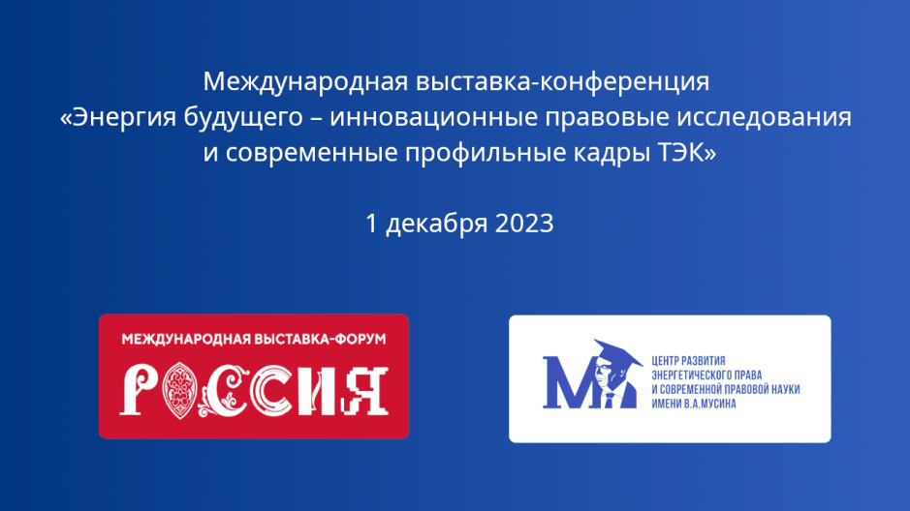
01.12.2023 Moscow
VDNKH
Pavilion No. 46
"Energy of Life"
Conference room
The event starts at 12.00
Registration of participants from 11.30.
Welcome coffee: from 11.30 to 11.55.
Link for online participants:
https://us06web.zoom.us/meeting/register/tZUscOyrpjsoG9DUUtNPiW9QVgotaXWVI2xU

The opening of the event and the award ceremony of the participants of the All - Russian Competition of Fuel and Energy sector young scientists’ publications- State Secretary - Deputy Minister of Energy of the Russian Federation - Anastasia Borisovna Bondarenko
Welcome addresses and speeches:
Presentation of achievements of the ANO "Research Center for the Development of Energy Law and Modern Legal Science named after V.A. Musin" - Academician of the Russian Academy of Sciences, Doctor of Law, Professor - Andrey Gennadievich Lisitsyn-Svetlanov – presentation of the monograph "Legal support for the implementation of climate projects in the Russian Federation and abroad"
Welcome speech and report – Corresponding member of the Russian Academy of Sciences, Doctor of Law, Professor, Honored Scientist of the Russian Federation, Honored Lawyer of the Russian Federation, Judge of the Constitutional Court of the Russian Federation (retired) - Mikhail Ivanovich Kleandrov. Report on the topic: "Fundamental problems of energy law". Online participation
Presentation of achievements of the ANO "Scientific Research Center for the Development of Energy Law and Modern Legal Science named after V.A. Musin" in the field of science and education - Victoria Valeryevna Romanova Director of the ANO "Scientific Research Center for the Development of Energy Law and Modern Legal Science named after V.A. Musin"
Welcome speech from Rossotrudnichestvo – Advisor of the Organizational and Analytical Department of the Federal Agency for the Commonwealth of Independent States, Compatriots Living Abroad, and International Humanitarian Cooperation - Andrey Mikhailovich Muravyev.
Welcome speech from the Russian Foreign Ministry – Deputy Director of the Department for Russian Compatriots Affairs Ivan Igorevich Nechaev
Welcome speech from the Association of Lawyers of Russia – Deputy Chairman of the Board of the Association, Adviser to the President of PJSC "Transneft" – Zhunus Amanzholovich Dzhakupov
Welcome speech – Director of the Research Institute of Energy Industry and Energy Law "One Belt and One Road" of Hebei Technological University Gao Yu (People's Republic of China) - simultaneous translation
Welcome speech – Chairman of the Management Board of Smart Energy Company - Li Viacan (People's Republic of China) simultaneous translation
Welcome speech and presentation - Managing Partner of Bosca Law, Head of the Institute of Energy Law Research, Head of Energy Disputes Arbitration Centre, Süleyman BOŞÇA, (Republic of Turkey). Report on the topic - "A New Perspective on Energy Disputes within the EDAC Framework" simultaneous translation.”
Welcome speech and presentation - Professor of Law, Coordinator of the Center for Environmental Law, Education, Research and Advocacy of the National School of Law of the Indian University - Dr. Sairam Bhat (India). Report on the topic – "Why energy security should be affordable, acceptable and sustainable" - simultaneous translation
Welcome speech and presentation from the Department of Energy of the Eurasian Economic Commission – Svetlana Viktorovna Zaitseva, Head of the Department of Electric Power and Nuclear Policy of the Department of Energy. Report on the topic: "Innovations in the law of the EAEU in the electric power industry"
Welcome speech and presentation – Doctor of Law, Professor, Chief Researcher of the ANO "Research Center for the Development of Energy Law and Modern Legal Science named after V.A. Musin" - Oleg Aleksandrovich Gorodov. Report on the topic: "Attributes of generation inthe electric power industry"
Welcome speech and presentation from JSC "St. Petersburg International Commodity Exchange" - Vice President of JSC "SPbMTSB" - Elena Alekseevna Sidorova. Report on the topic: "Exchange trading of energy resources"
Welcome speech and presentation from Gazprom PJSC - Deputy Head of the Department Snezhana Mikhailovna Saushkina. Report on the topic: "Trends in the development of digitalization of procurement activities of energy companies"
Vyacheslav Viktorovich Sevalnev, Candidate of Law, Leading Chief Researcher of the ANO "Research Center for the Development of Energy Law and Modern Legal Science named after V.A. Musin". Report on the topic: "Legal regulation of the implementation of climate projects and the turnover of carbon units under the legislation of the People's Republic of China"
Welcome speech from PJSC "Mosenergo" - Deputy Managing Director – Director of Legal Affairs of PJSC "Mosenergo" Anna Aleksandrovna Efimova
Affairs of PJSC "MOEK" Alexey Shamilevich Sharafutdinov
Welcome speech from PJSC "Inter RAO" - PhD, Head of the Directorate of Regulatory Support of the Center for Legal Work of the complex of PJSC "Inter RAO" - Nikita Aleksandrovich Zhabin
Reports:
Yuri Arkadyevich Kapul, Deputy Head of the Department of PJSC Transneft, postgraduate student of the ANO "Research Center for the Development of Energy Law and Modern Legal Science named after V.A. Musin". Report on the topic: "Some problems of legal regulation of zones with special conditions for the use of territories of trunk oil pipelines"
Nikita Aleksandrovich Yatsenko, Deputy Director of the Legal Department of PJSC "Transneft". Report on the topic: "On the legal nature of pipeline protection zones"
Maria Aleksandrovna Pyatykh is a postgraduate student of the ANO "Research Center for the Development of Energy Law and Modern Legal Science named after V.A. Musin". Report on the topic: Practical issues of legal regulation of compensation for environmental damage from oil and petroleum products pollution
Denis Sergeevich Romanchenko postgraduate student of the ANO "Research Center for the Development of Energy Law and Modern Legal Science named after V.A. Musin" Report on the topic: "Prospects of nuclear energy regulation regarding the concept of sustainable development"
Ksenia Igorevna Khachaturova, Head of the Department of Legal Support of commodity and Futures Markets of JSC "SPbMTSB", postgraduate student of the ANO "Research Center for the Development of Energy Law and Modern Legal Science named after V.A.Musin". The topic of the presentation: "The exchange, the regulator or the market - who regulates the ethical behavior of participants in exchange trading in the commodity market?"
Lidiya Vladimirovna Samukova, postgraduate student of the ANO "Research Center for the Development of Energy Law and Modern Legal Science named after V.A. Musin" Report on the topic: "Thermal energy (power) as a special object of civil rights"
Sergey Yuryevich Komarov, postgraduate student of the ANO "Research Center for the Development of Energy Law and Modern Legal Science named after V.A.Musin" Report on the topic: "The legal regime of nuclear and radiation hazardous facilities in Russian legislation"
Nikolay Sergeyevich Zuev, Head of the Department of JSC "Sogaz" Postgraduate student of ANO "Research Center for the Development of Energy Law and Modern Legal Science named after V.A. Musin" Report on the topic: "Telematics systems, smart insurance"
Anastasia Yuryevna Bogdanova, Advisor to the Department of Economic Security in the Fuel and Energy Complex of the Ministry of Energy of Russia. Report on the topic: "Legal provision of consumer rights protection in the retail electricity market in the Russian Federation and abroad"
Nazar Charyevich Saparov is the head of the Department for Support of Activities in Retail electricity Markets of the Legal Department of LLC "Transneftienergo". Report on the topic: "The legal nature of energy as an object of an energy supply contract and the purchase and sale of electricity"
Alina V. Kartukhina, Legal Adviser of the Legal Department of PJSC "Transneft". Report on the topic: "Application of the institute of subsidiary liability in the bankruptcy of fuel and energy complex companies"
Alina Andreevna Leshchinskaya - Legal Adviser of Gazprom Dobycha Irkutsk LLC Report on the topic: "Legal regulation of carbon units and transactions with it"
Nikolay Nikolaevich Toropov is a legal adviser of the Gazprom Transgaz Saratov branch. Report on the topic: "On the issue of regulatory regulation of requirements for the submission of project documentation for hazardous production facilities"
Yana Aleksandrovna Mitulinskaya is a leading specialist of Gazprom Transgaz Tomsk LLC. Report on the topic: "Problematic aspects of establishing a public easement for the placement of linear objects "
Amina Dzhambulatovna Batyzheva - Senior Associate of the Industrial Safety and Labor Protection Practice of Gazpromneft Expert Solutions LLC. Report on the topic: "Actual problems of legal regulation of the oil industry complex"
Zlata Eldarovna Zagorulko, Chief Legal Adviser of the Judicial Practice Department of JSC AtomEnergoSbyt. Report on the topic: Delineation of responsibility for poor-quality supply of electric energy between the guaranteeing supplier and the network organization"
The list is being updated.
Summing up the results of the conference by the members of the organizing committee 15.45.
16.00.16.20 – coffee time
16. 20 -17.00 excursion "Achievements of the fuel and energy sector" in Pavilion 46. 2nd floor.

